mmddyy

PERSONAL INJURY PHYSICIAN’S COVER LETTER – Pediatric Patient

Claim #

RE: Patient: Firstname Lastname
Date of Loss: dateofloss

The following is a Personal Injury Physician’s Cover Report (From office visit on 3-7-2018). It contains information to assist you in handling this case.

Overall Diagnostic Impressions:

- Cervical myositis and spasm related to 6
- Head feels too heavy as related to 6
- Neck pain as related to 6
- Jaw pain as related to 6
- Difficulty sleeping as related to 6
- Type I, Grade II, Stage II, traumatic cervical acceleration-deceleration injuries

Diagnostic Codes:
V4959 Passenger in motor vehicle collision
S134xx Sprain of ligaments of the Cervical spine, initial
M530 Cervicogenic Headaches
M542 Cervicalgia
M62838 Other muscle spasm
M9901 Segmental somatic dysfunction Cervical spine
M9902 Segmental somatic dysfunction Thoracic spine
M9903 Segmental somatic dysfunction Lumbar spine
M4012 Cervical Kyphosis
V4959xa Passenger in motor vehicle collision

Add more here

Causation:

The rapid acceleration/deceleration of the head and torso can cause the suspensory Temporal-mandibular joint to move beyond it’s normal limits. The seatbelt suddenly stopping the torso from forward movement whips the neck causing injury to supporting soft tissue. Being thrown back against the rear seat and head restraint often causes a posterior kyphotic hyper-stretch resulting in an “s” curve in the neck – a telling sign of an auto accident-related whiplash injury.

Treatment Plan:

Treatment is being rendered to reduce and relieve pain, improve his condition, and to rehabilitate the injured structures. Symptoms and examination did not reveal numerous signs of injury. The treatment program is intended to reduce structural degeneration. The goal is to rehabilitate, re-educate, and strengthen the injured tissues in an economical fashion and in the shortest time possible. Specific, gentle, mobilizing spinal adjustments will be used as appropriate. Recommending treatment be more conservative than diagnosis due to the advantage of her young age. 5x 1 weeks, 3x 4 weeks, 1x 4 weeks.

Comments and Prognosis:

See parent’s initial report for collision details.

It is my opinion based on the history and examination, that this patient has sustained injuries (though minimal) that are 100% a result of the motor vehicle accident on dateofloss. This patient was in good to excellent condition prior to this accident. There is little research regarding children involved in motor vehicle collisions other than mortality. The best related studies would be shaken baby syndrome; however, these studies currently do not offer a grading system for severity. Case studies across the country and research by Dr. and Author, R. Jay Shetlin have revealed early degenerative joint and disc disease present in adolescents within ten years following motor vehicle collision injuries when said injuries go untreated. For this reason, I recommend at least minimal early-intervention treatment for children following a Motor Vehicle Collision.

Sincerely,

Doctor’s Name
++ Certified motor vehicle occupant injury physician
++ Certified by The Whiplash Group
++ Certified by Personal Injury Training Institute
++ Certified with Croft (there is no testing to show certification)
++ Certified with Chiropractic Personal Injury Specialist (CPIS) via the ICA

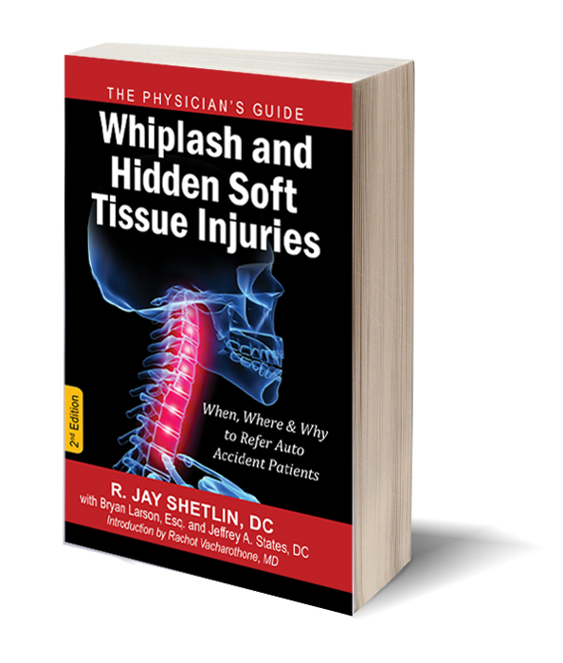
Suggested research reading
Available at Amazon.com and
DrJayShetlin.com

